Screenshot - 01 for step No.4.1.1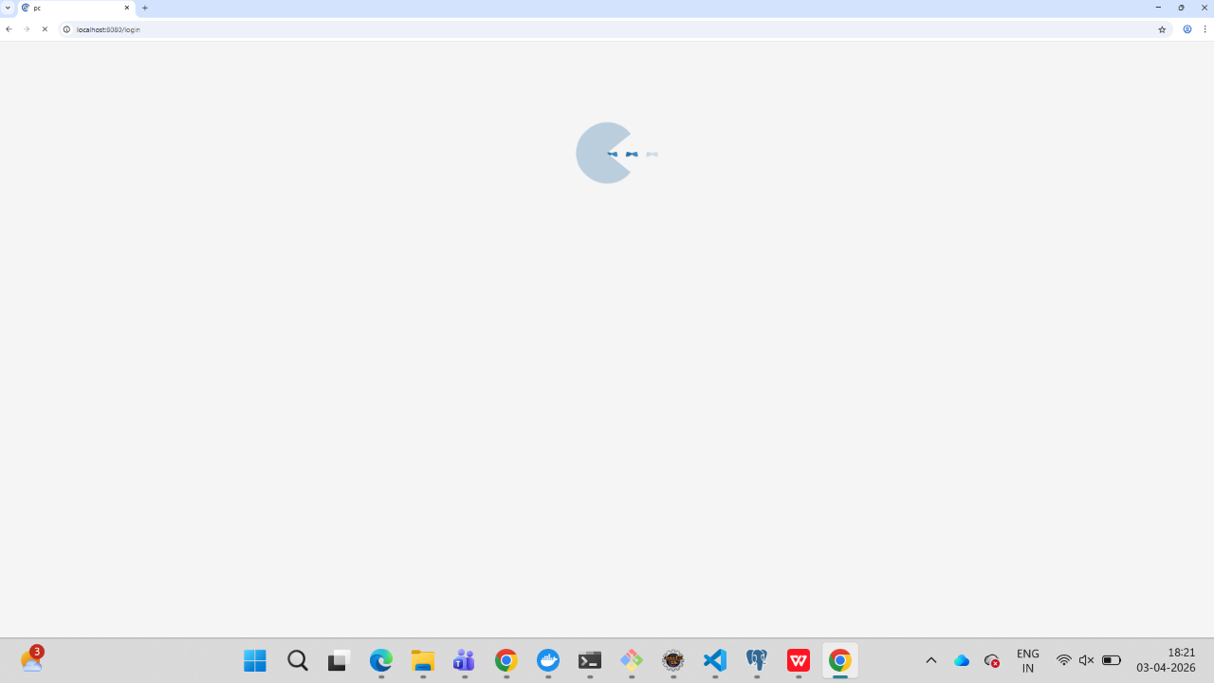
Screenshot - 02 for step No.4.1.1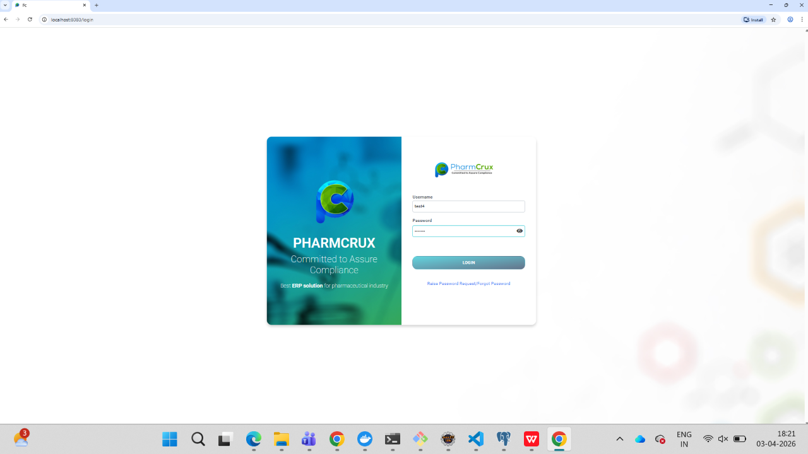
Screenshot - 03 for step No.4.1.1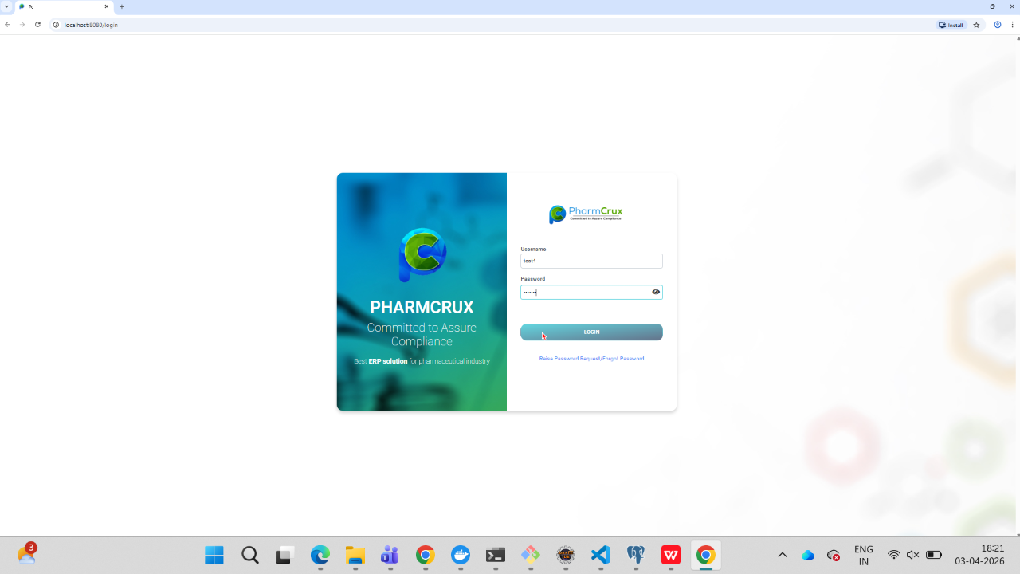
Screenshot - 04 for step No.4.1.1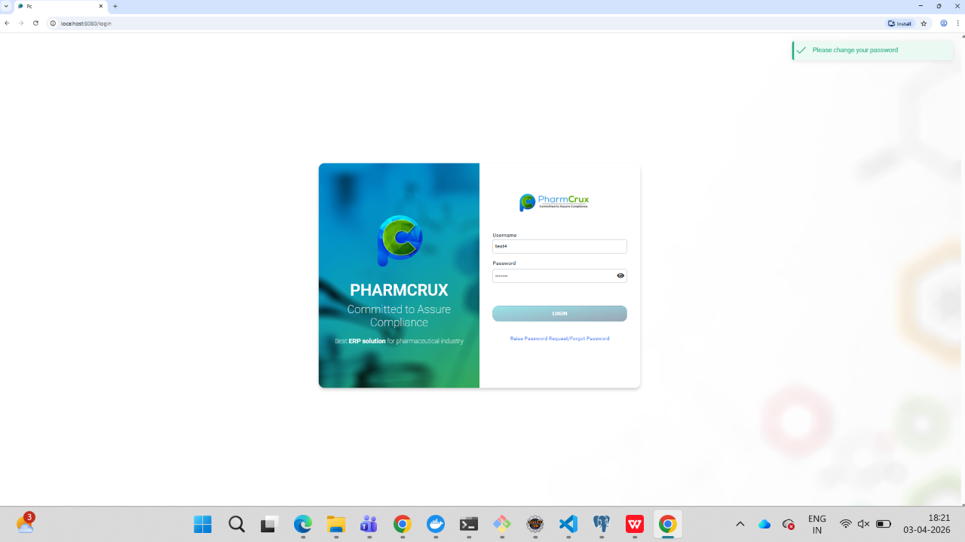
Screenshot - 01 for step No.4.1.2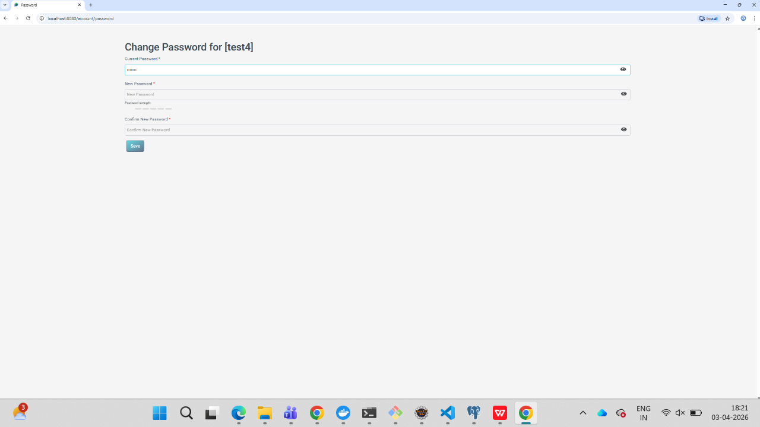
Screenshot - 02 for step No.4.1.2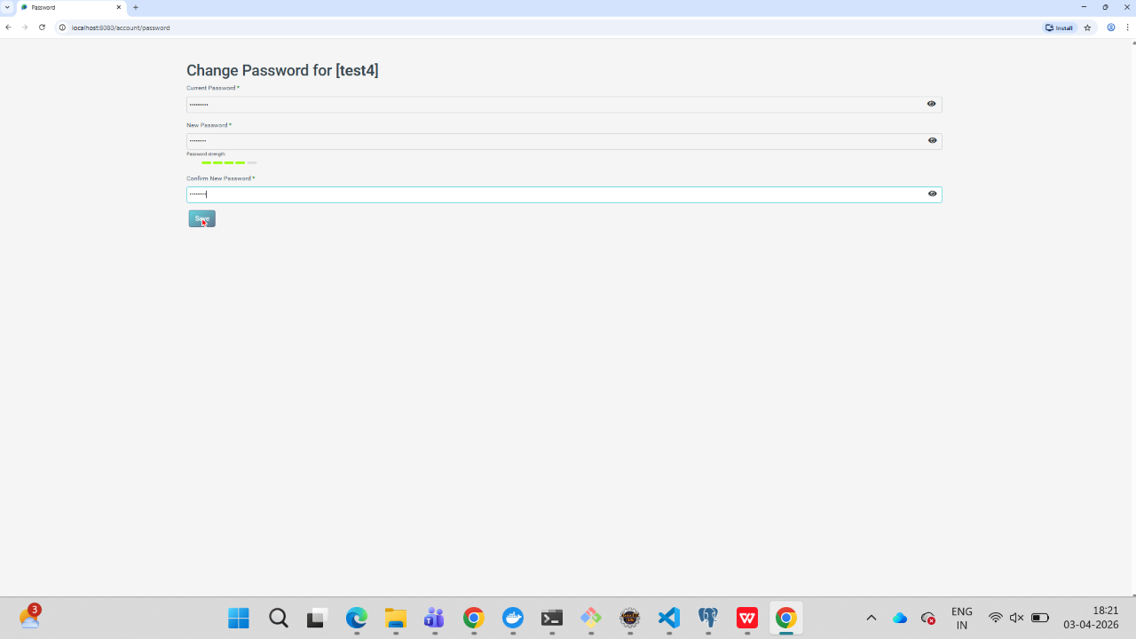
Screenshot - 03 for step No.4.1.2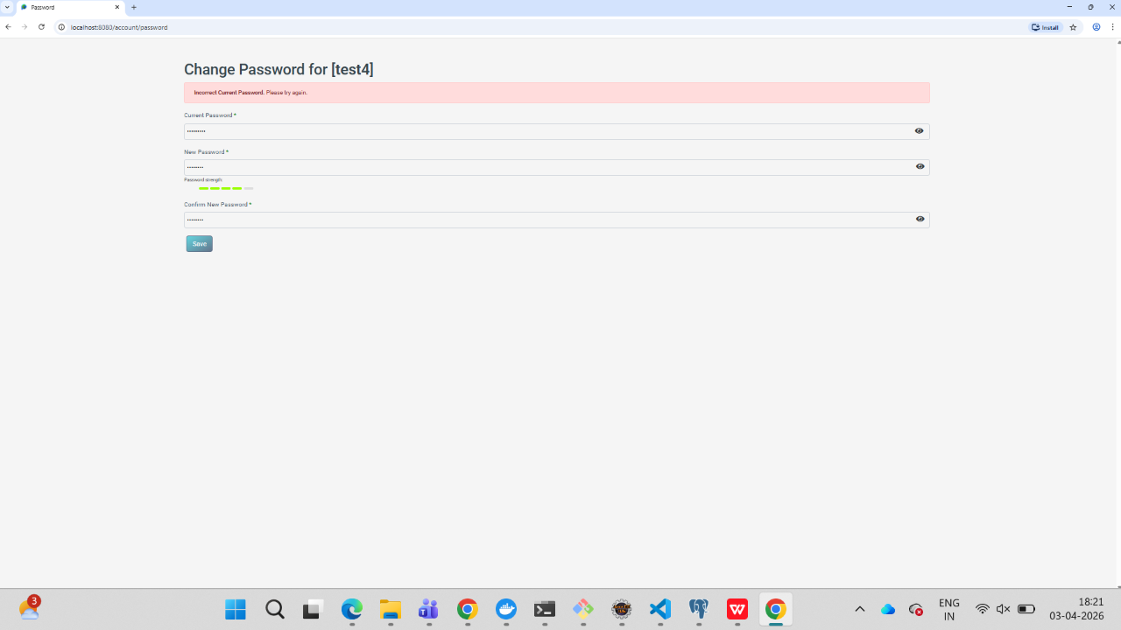
Screenshot - 01 for step No.4.1.3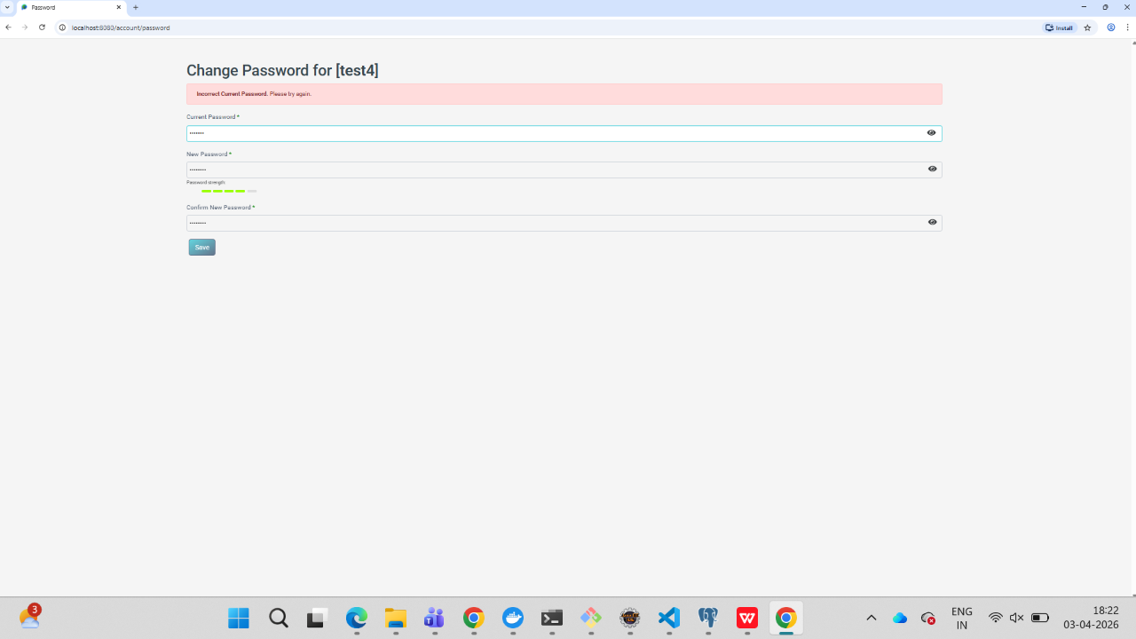
Screenshot - 02 for step No.4.1.3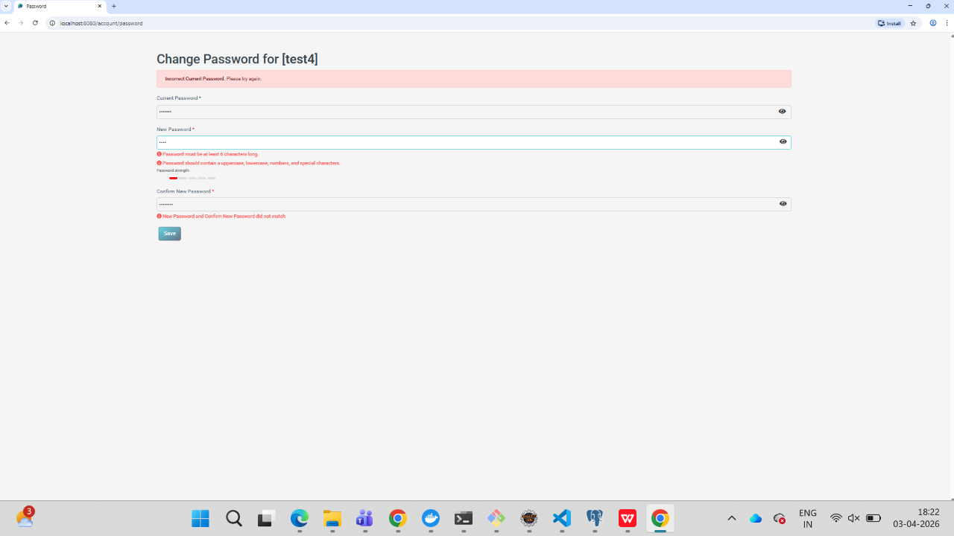
Screenshot - 03 for step No.4.1.3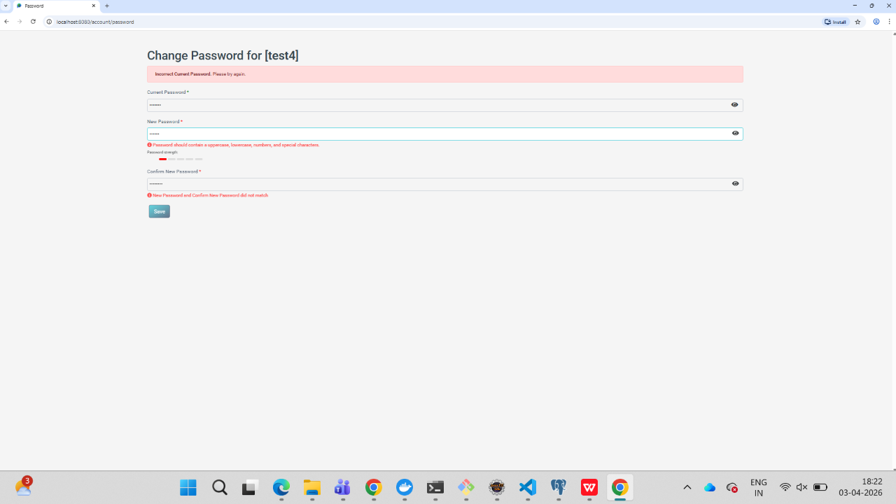
Screenshot - 04 for step No.4.1.3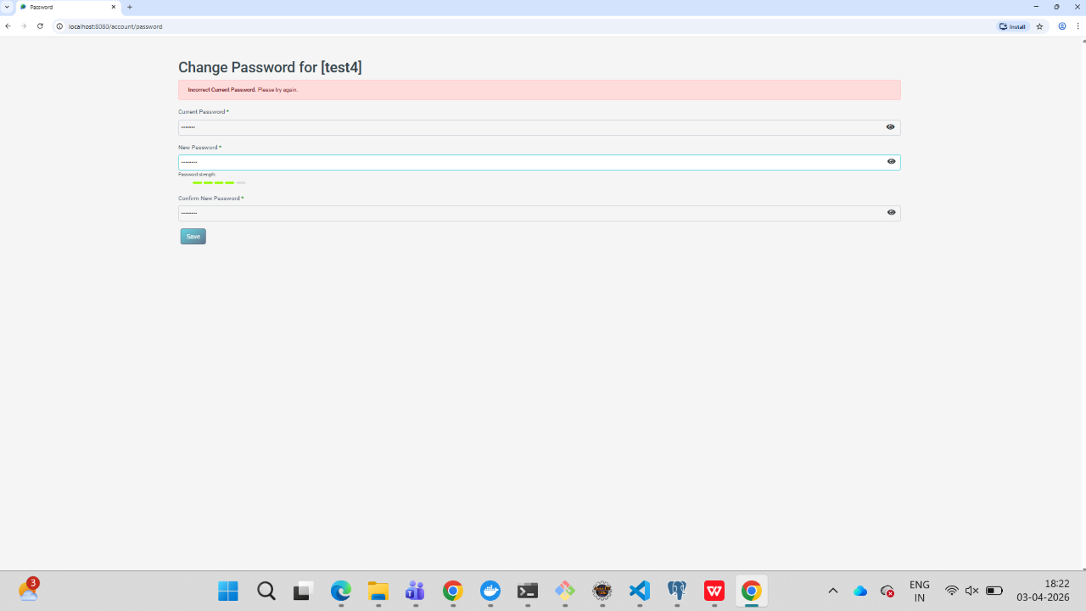
Screenshot - 05 for step No.4.1.3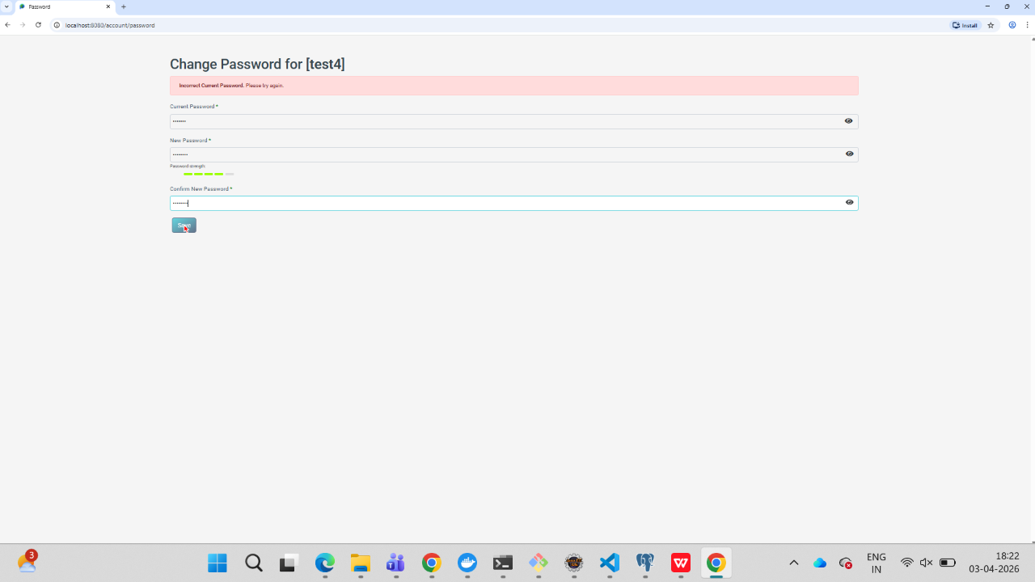
Screenshot - 06 for step No.4.1.3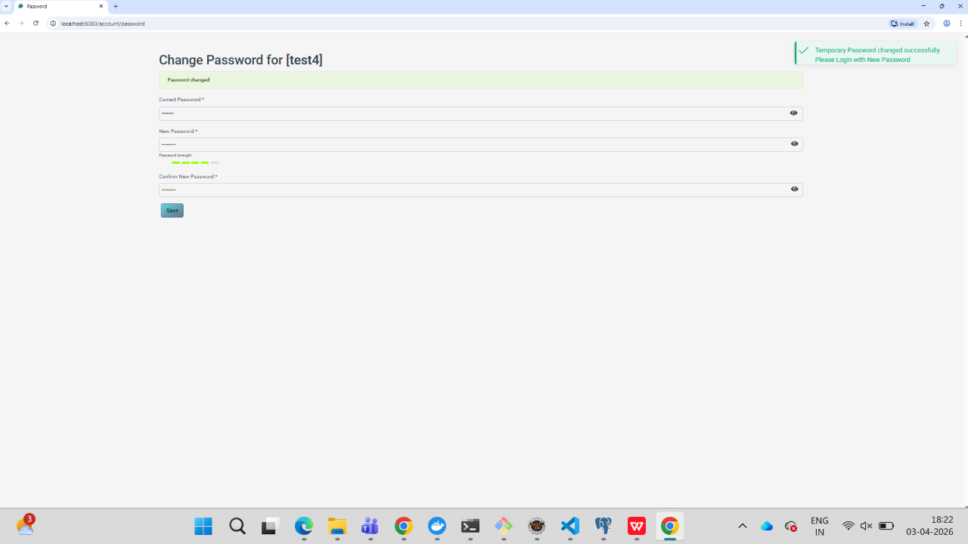
Screenshot - 07 for step No.4.1.3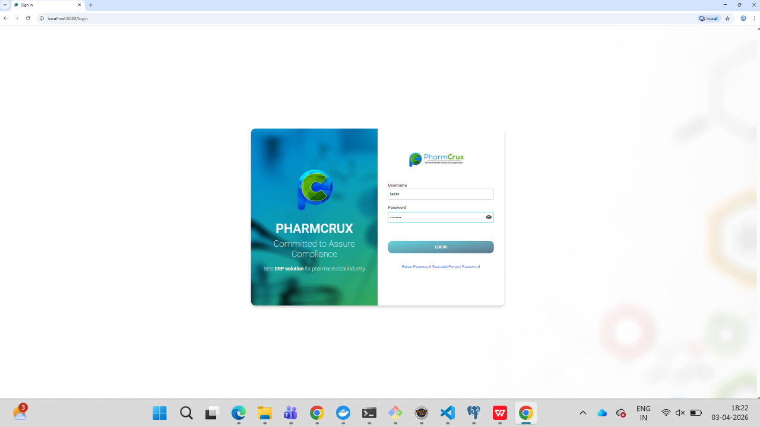
Screenshot - 08 for step No.4.1.3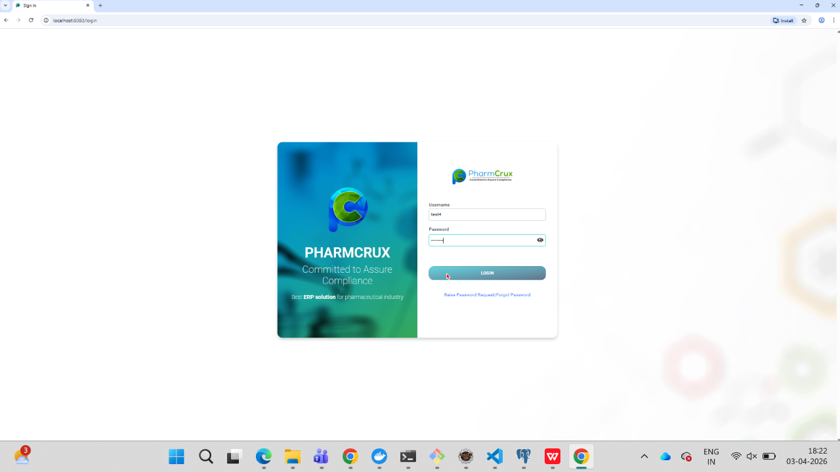
Screenshot - 09 for step No.4.1.3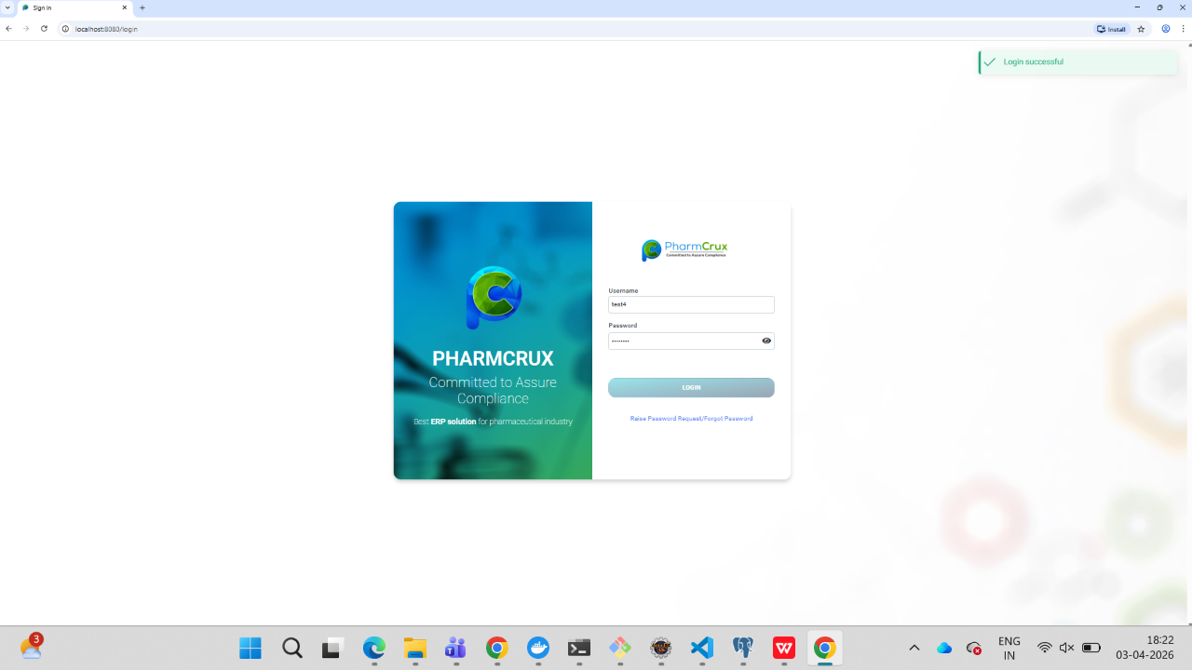
Screenshot - 01 for step No.4.1.4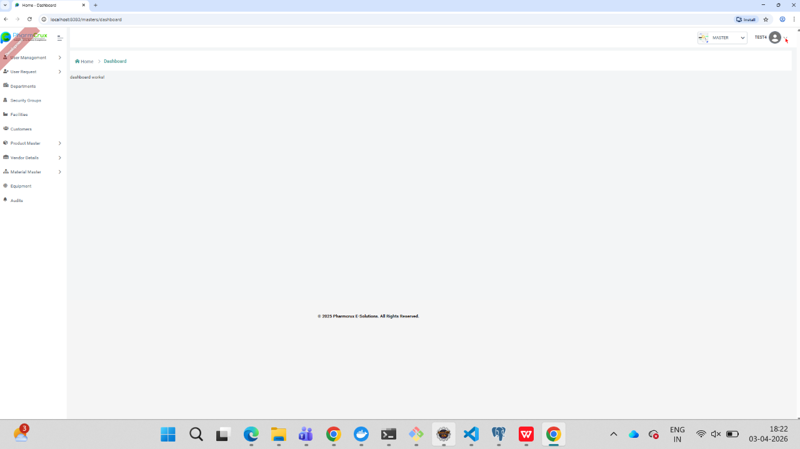
Screenshot - 02 for step No.4.1.4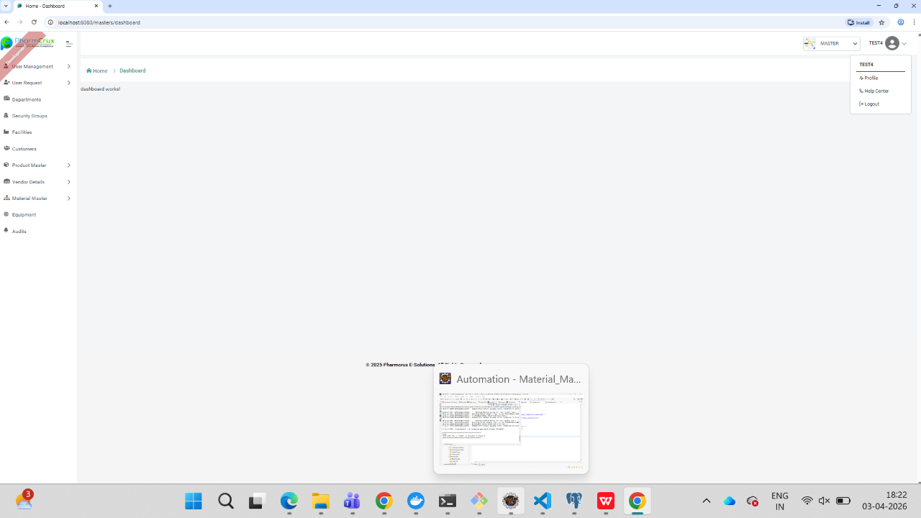
Screenshot - 03 for step No.4.1.4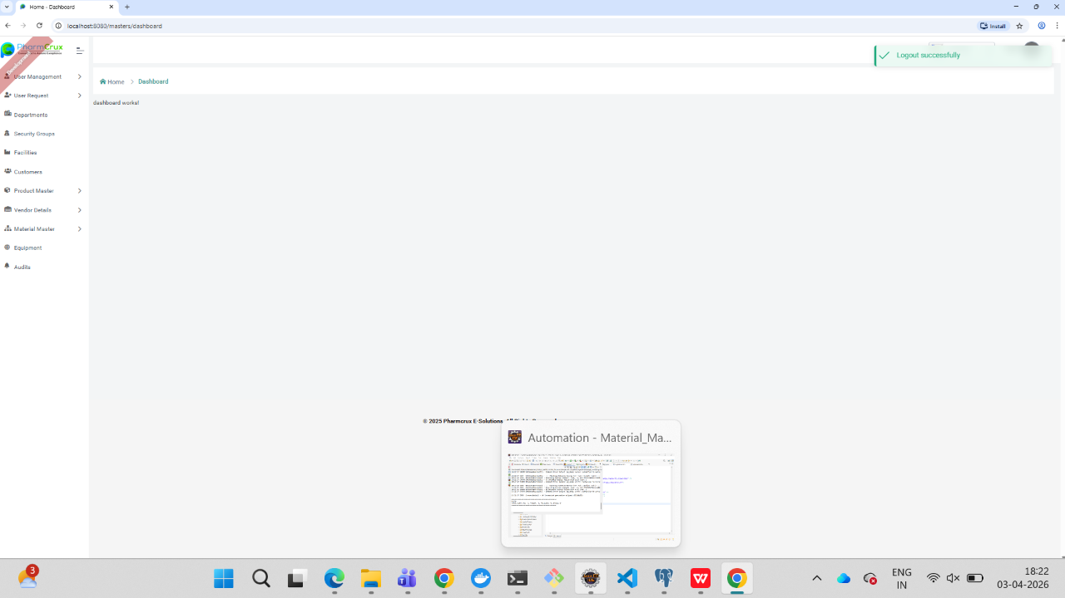
Screenshot - 04 for step No.4.1.4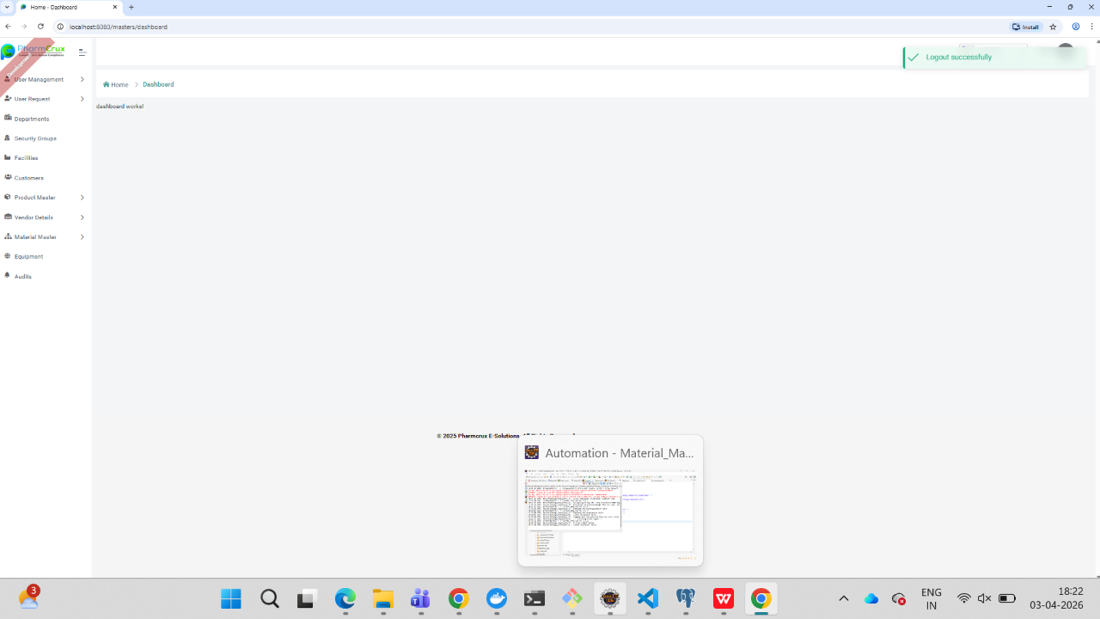

Test Duration Details: | Start Date : |  | End Date:
 | Total Screenshots : |  | No. of Testers:
Remarks:

Executed by
 | Name | Title, Department | Signature | Date

Reviewed By
 | Name | Title, Department | Signature | Date

Reviewed By
 | Name | Title, Department | Signature | Date

Approved By
 | Name | Title, Department | Signature | Date

